HOW TO PLAY ROULETTE
Roulette is a game that you can learn in two minutes and have fun immediately with the same chance of winning as the player who has been playing for years. Some bets have higher chances of winning (odds) than others. Proper game etiquette dictates that you may only place bets on the table when the dealer tells you to. It is prohibited to place any bets while the dealer is still paying bets from the previous spin. Once the pill (ball) starts its descent into the grooved portion of the wheel, the dealer will wave their hand over the betting board and say “no more bets”. When the wheel stops spinning, the dealer will announce the winning number, color, and odd or even. The dealers’ silent sign of permitting bets to be placed is when they remove the marker from the board. The marker is a 3 – 4” crystal or plastic piece the dealer uses to “mark” the winning number.
Each player will receive a certain number of Roulette colors (chips) with a predetermined value based upon the players wishes. Each colored chip will be worth the same so if you tell the dealer you want $5.00 chips and hand them $100.00, they will give you 20 chips of a color that will be exclusive to you. For the purpose of this instruction, we will say you are receiving pink chips. The dealer will send you 20 pink chips. The dealer will then mark a pink chip with a $5.00 chip. You will be the only player using pink chips so the dealer will know that all pink chips are worth $5.00.
The Roulette table betting board is comprised of two different components. The inside board and the outside board. The outside board is where you will find the smallest odds but the easiest bets. You have column bets, dozen bets, odd / even bets, and red / black bets. Column bets and dozen bets pay two chips for every one chip you bet so the odds are two to one. Odd / Even bets and Red / Black bets pay one chip for every chip you bet thus being known as even money. The column bets can be found at the bottom of the betting board at the base of each column. The dozen bets are along the side and are marked “first twelve”, “second twelve” and “third twelve”. The odd / even bets and red / black bets are on the outside along the side are very self explanatory.
The inside board is where the numbers are. There are 36 numbers, 1 zero, and 1 double zero for a total of 38 possibilities. The payouts are based upon 1:35 for each number bet placed straight up. For example, if the five comes up, the straight-up bet on the five would pay 35 chips for every chip you wager, the middle column bet would pay 2 chips for every chip wagered, the red bet would pay two chips for every chip wagered, and the odd bet would pay even money. You can also place combination bets on the inside board. The pay-outs decrease but your odds of winning greatly increase. If you place your wager on the line between two numbers, this is called a side bet and pays 17:1 (2 opportunities to win). A wager placed on the corner of four numbers is called a corner bet and pays 8:1 (4 opportunities to win). The wager placed on the far outside line of the first column of numbers is called a line bet and pays 11:1 (3 opportunities to win). There is only one way to place a five number bet and that is on the line between the zero and the one. You will win when the 0, 00, 1, 2, or 3 comes up. This bet pays 6:1 (5 opportunities to win). And the last type of wager is a six number bet and is when the player puts their wager on the corner of two numbers on the very outside line of the betting board. This bet pays 5:1 (6 opportunities to win).
A Roulette Thing To Try
Unlike craps or blackjack, roulette is more of a "spectator sport". Your only involvement in game play is placing your bet (chips) on the layout. The dealer does all the work. Note that due to it's French origins, a roulette dealer is called a croupier (pronounced croop-ee-ay). Also unlike blackjack, you can still play if there are no open seats at the table. You'll just have to reach in between two seated players to place your bets.
Every roulette table has a lighted board that shows which number came up on the most recent rolls. What does this board really tell you? Absolutely nothing. The "law of independent trials" dictates that each roulette play is completely random and has nothing to do with any previous plays. Just because red came up the previous six times doesn't mean black is "due" to come up. Red has as much chance of coming up on the next play as it did the previous six plays. The wheel has no memory. Those lighted boards are there for the casinos advantage, not yours. Why? Because people don't know about the law of independent trials and if they see one color come up several times in a row most of them will bet the opposite color, and lose. The casinos put those boards up because they win more when players pay attention to them. In short, ignore the lighted boards.
Some gambling books claim that you can spot "tendencies" in certain wheels to come up one way or another. That's hog-wash. The casinos make their money due to the randomness of the game and if any such tendency did start to develop (due to wear and tear on the wheel) they would immediately replace it. The casinos, and the Nevada Gaming Commission, go to great lengths to ensure that no such wheels exist.
Roulette has a high house edge (over 5%) due to the '0' and '00' locations on the wheel. As a result, you don't want to spend a lot of time at a roulette table because the longer you play the better chances are the odds will catch up with you. However, playing roulette is fun, and the little routine I have outlined here will give you a chance to enjoy the game and possibly make a little money in the process.
- You may have to hunt around the smaller casinos to find a table with a $2 minimum bet level. Most major resorts on the Strip have $5 minimums. You may also be able to find a table with a $2 or $1 minimum at the older resorts on the north end of the Strip or downtown. The following scenario uses a $2 minimum bet level, but if you find a $1 minimum table just cut the amounts in half.
- Put $62 down on the table and tell the croupier you want "a color". (That's 62 one-dollar colored chips. Each player has their own color.)
- Put the chips in the following stacks; 2, 4, 8, 16, 32.
It's best not to have a towering stack of 32 chips sitting there while you're playing because it could easily get knocked over and create a mess. Instead:
- count out 8 chips and put them in a stack
- then create six more stacks of the same height
- put the six chips you have remaining in stacks of 4 and 2

You will now have seven stacks of 8 chips. This way you can stack up two of the 8-chip stacks to create the 16-chip stack, and four of them to create the 32-chip stack, once it's time to bet
them. You'll want to keep your 8-chip stacks grouped according to their bet though, so you don't lose track of which bet you're on (see the diagram where the number on the chips represents how many chips are in the stack). Note that when you do go to place the 16 and 32-chip bets you do have to stack them up into one tall stack before sliding them onto your position on the layout.
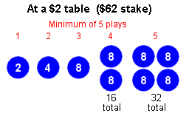 |  | 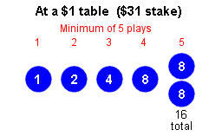

- Pick one of the three "dozen" bet positions ('1st 12', '2nd 12', '3rd 12') or one of the three "column" bet positions. Both dozen and column bets cover 12 numbers and pay 2:1.
- 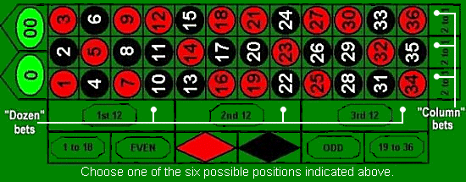
- Play your chosen dozen or column bet position in a progressive manner as follows (stick with the same dozen or column position throughout this series):
- Start out by placing the $2 stack of chips on your position
- Each time you lose, bet the next stack of chips (doubling your bet) on your position
- Each time you win, START OVER. i.e. use part of your winnings to replace any lost stacks of chips so that you again end up with stacks of 2, 4, 8, 16, and 32, and bet the $2 stack. Set aside any chips you have left over after replenishing your stacks. These are your "winnings".
- Continue playing until you must bet (due to four consecutive losses) the stack of 32 chips. Win or lose on this bet, cash out and walk away.
The reason I say "walk away" is because of roulette's high house edge so the longer you play the more likely you are to lose any gains you may have made.
Because the dozen and column bet positions pay 2:1, if you hit a hot streak you could do quite well with this little routine. The possible outcomes are:
Worst case - you lose on five consecutive spins and you're out $62 (it happens)
Not so bad - you win some of the lower bets but lose on the $32 spin coming out up or down
Even better - you lose on the first four spins but win on the $32 spin and walk away with $96
Best case - you win a lot of the lower bets and hit on the $32 spin and walk away with double or possibly even more your original stake
It is getting harder and harder to find anything less than a $5 roulette table. What if you can't find a $2 or $1 table? You can still try this progressive game without risking a lot of money. However, you'll only have four minimum plays rather than the five minimum plays the $2 and $1 tables give you. This is a full 20% reduction in the number of chances you have for the ball to land on your chosen "dozen" or "column" position so you may want to search out a $2 or $1 table. (You could go to five plays on a $3 table but that would require a stake of $93.) But if you can't find a $2 or $1 table, or you're just short on time, you can still do well if luck is on your side. Here's how you would play a $3 table and a $5 table.
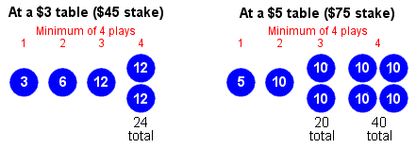
Another alternative I like to play at a $5 table is to wager a little more ($95) and have a minimum of five plays. You basically set up your chips for a table with a $3 minimum but just add $2 to your first bet to meet the table minimum.
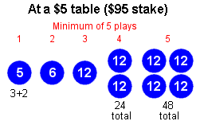
Notes
When the ball starts to drop the croupier will wave their hand over the layout indicating that no more bets can be placed. Any chips placed on the layout after that will not be counted in the current play.
When the ball drops onto a number the croupier places a plastic marker on the winning number, collects losing bets and pays winning bets. Wait until the croupier removes the plastic marker before picking up any winnings or placing the next bet. If you're ahead when you finish this routine, remember to tip the croupier when you cash out and walk away.
If you're just passing through and you want to place a quick bet on a certain number or on one of the other areas of the layout, you don't have to ask the croupier for a color. It is perfectly acceptable to put the house's chips, or even cash, down on the layout. Note that the red, black, odd, even, 1-18, and 19-36 areas of the layout pay even money. The individual numbers pay 35:1, but only have a 1:38 chance of coming up.

